

**GEO WEEK 2022**

**31 October – 4 November 2022**

ACCRA INTERNATIONAL CONFERENCE CENTER, GHANA

**EXHIBITION SERVICES GUIDE**

**AND BOOTH REQUEST FORM**

# Sample booths

We will brand exhibition booths in advance of your arrival for the exhibition set-up.

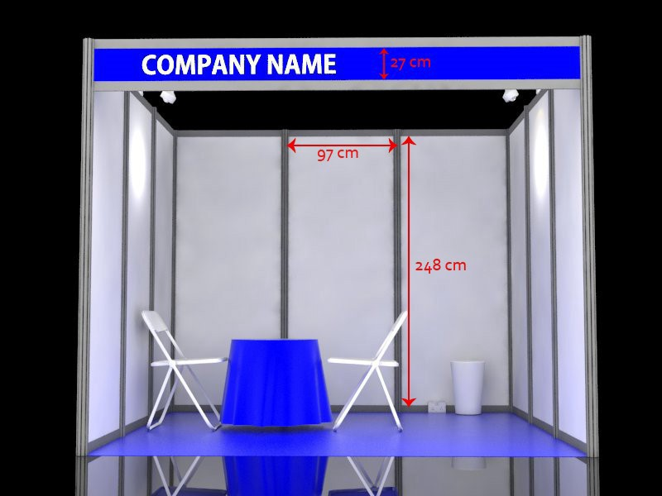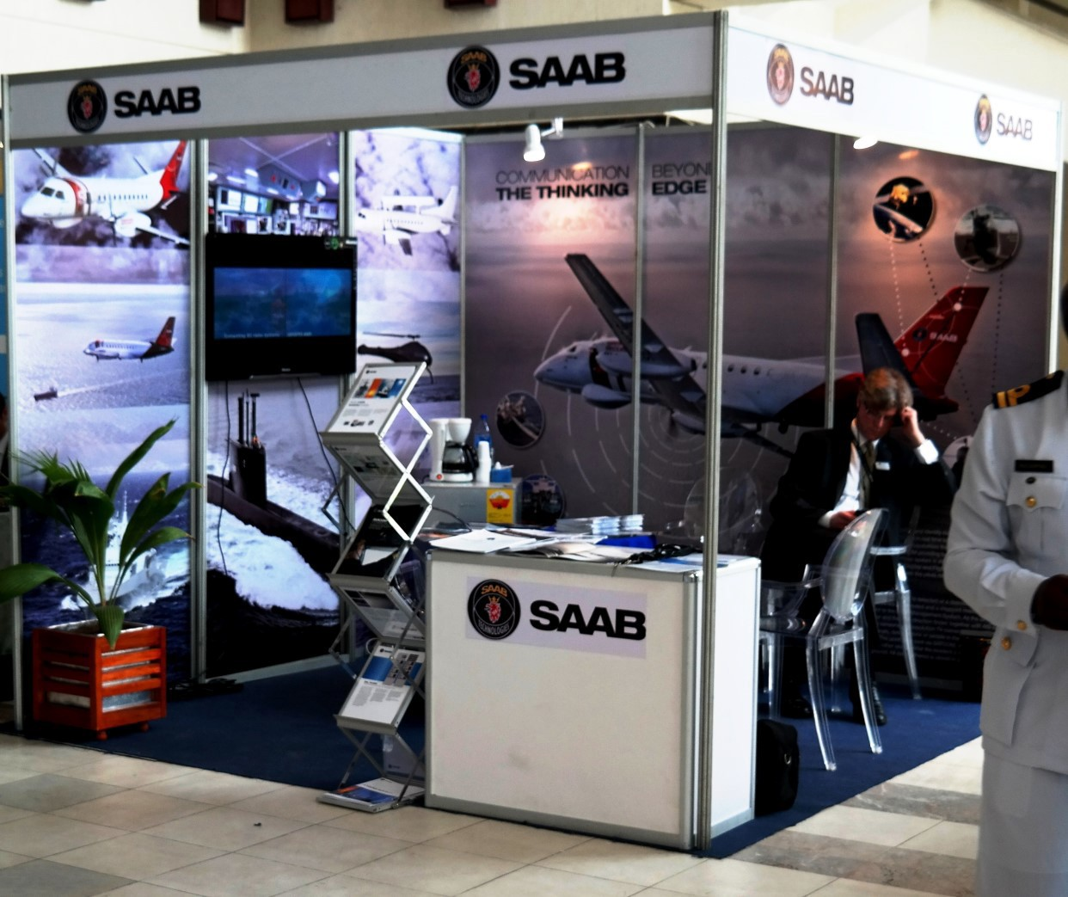

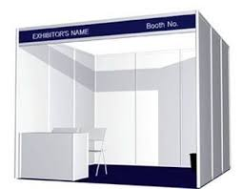

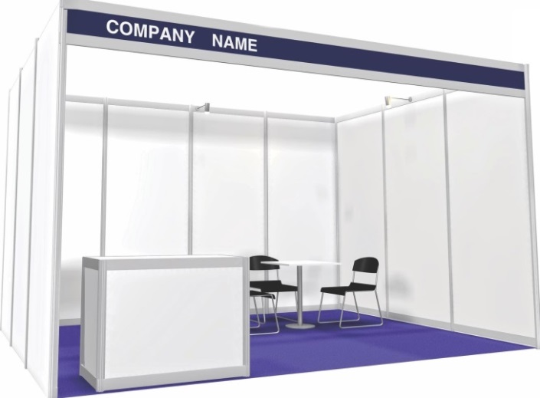

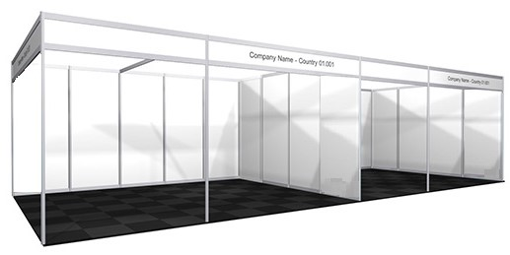

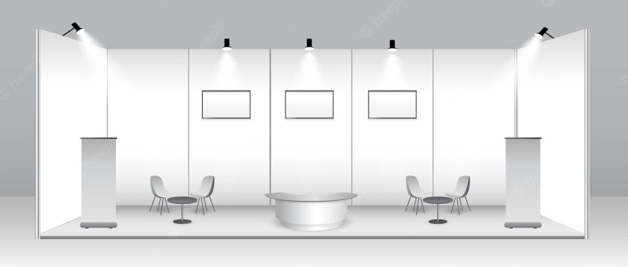

# Prices

|  |  |  |
| --- | --- | --- |
|  | **Description** | **Unit Cost USD**  **per day** |
| 1 | Standard booth: 9 square meters (3 shell scheme)   * table * 2 chairs * 2 spot lights * carpet * rubbish bin * 2 power sockets * fascia name including logo | 675 |
| 2 | Printing and installing graphics on booth panels. (97cm x 248cm) | 80 (one off cost) |
| 3 | Customized booths according to company’s designs and specifications | To be discussed with the event secretariat |
| 4 | Additional items. | Refer to cost table below |

**Note**:

Multiple booths may be requested to create a larger space. If exhibitors require a slightly larger booth, the cost per square metre is 75 USD per day. Please contact the organizers to discuss your requirements.

Standard measurements for booth panels are 248cm (H) x 97cm (W). Fascia’s have a printable area of 27 cm from top to bottom.

Send high resolution versions of your print-ready artwork to [geoweek22exhibition@gmail.com](mailto:geoweek22exhibition@gmail.com) via your preferred ftp site, Dropbox, or Google share drive.

# ADDITIONAL ITEMS:

# FURNITURE & ACCESSORIES

|  |  |  |  |  |
| --- | --- | --- | --- | --- |
| 001 counter unit  $80 | 002 set of 3 shelves  $55 | 003 folding table with cloth $20 | 004 folding chair  $30 | 005 tub chair  $80 |
|  |  |  |  |  |
| 006 glass topped meeting table/chairs  $180 | 007 pedestal bar stool black/white $40 | 008 pedestal bar table $45 | 009 fridge 50cms x 50cms x 85cms  $70 | 010 coffee maker  $60 |
|  |  |  |  |  |
| 011 32” LCD monitor with HDMI cable floorstand  $150 | 012 42” – 55” LCD with VGA /HDMI cable floorstand $180, $250 | 013 Optima/  Acer projector Ansi Lumens $150 | 014 screen 180cms x 180cms  $55 | 015 additional 13A plug point  $35 |
|  |  |  |  |  |
| 016 40” adjustable aim spotlight $42 | 017 1.2m single fluorescent light fitting $40 | 018 single phase consumer unit  $130 | 019 standing pedestal fan $45 | 020 continental trailer socket $30 |
|  |  |  |  | British Standard Power King 5 Way Extension Cord Socket With Switch - Buy Extension  Cables Socket,Multi Socket Extension Cord,Power King Extension Socket  Product on Alibaba.com |

URN

**FURNITURE & ACCESSORIES CONT’D**

|  |  |  |  |  |
| --- | --- | --- | --- | --- |
| 021 lockable door for storeroom 100cm x 250cm $115 | 022 additional shell scheme panels 100cmx 250cm $25 | 023 acrylic panel 100cm x 250cm  $45 | 024 lockable glass showcase 50cm x 50cmx 100cm $150 | 025 lockable glass showcase 100cm x 50cmx 100cm $170 |
|  |  |  |  |  |
| 026 podium 50cms x | 027 multi-tiered | 028 coat hooks for | 029 DVD player for | 030 graphic print / |
| 50cms x 100cms  $45 | literature rack $40 | use inside closet $20 | LCD’s 011/012  $45 | install 1 shell scheme 97cm x  248cm $80 |
|  |  |  |  |  |
|  |  |  |  |  |
| 031 pull-up banner—  print/install $295 | 032 flower basket with green plants $49 | 034 queue control barriers $35 |  |  |
|  |  |  |  |

|  |  |
| --- | --- |
| BOOTH REQUEST FORM  (Compulsory for standard shell scheme stand exhibitors) | Return this form to:  The Event Secretariat  Email: [geoweek22exhibition@gmail.com](mailto:geoweek22exhibition@gmail.com) |

|  |  |
| --- | --- |
| Company name |  |
| Company Address |  |
| Country / City |  |
| Telephone no. |  |
| Email address |  |
| Contact person |  |
| Number of booths requested |  |
| Additional space (square meters) |  |
| Additional Electricity Requirements |  |

**Furniture and accessories requested**

|  |  |  |  |  |  |  |
| --- | --- | --- | --- | --- | --- | --- |
| **no** | **Item** |  | **Qty** | **Unit cost USD per day** | **No. of days** | **Total cost USD** |
| 1 | Counter unit with shelf and lockable door |  | 80 |  |  |
| 2 | Shelf - set of 3 (1m wide) |  | 55 |  |  |
| 3 | Folding table with cloth |  | 20 |  |  |
| 4 | Chair |  | 30 |  |  |
| 5 | Tub chair (simulated white leather) |  | 80 |  |  |
| 6 | Meeting table/chairs (2) |  | 180 |  |  |
| 7 | Bar stools |  | 40 |  |  |
| 8 | Bar tables |  | 45 |  |  |
| 9 | Fridge 500mm (L) x 500mm (W) x 850mm (H) |  | 70 |  |  |
| 10 | Filter coffee maker with |  | 60 |  |  |
| 11 | 32” LCD HD monitor with VGA/HDMI cable |  | 150 |  |  |
| 11A | LCD monitor stand for above |  | 40 |  |  |
| 12 | 42” LCD monitor with VGA/HDMI cable |  | 170 |  |  |
| 12A | LCD monitor stand for above |  | 40 |  |  |
| 12B | 50” LCD monitor with VGA cable |  | 220 |  |  |
| 12C | LCD monitor stand for above |  | 40 |  |  |
| 12D | LCD wall mounting installation |  | 40 |  |  |
| 13 | Optima/Acer projector Ansi Lumens |  | 150 |  |  |
| 14 | Projector screen 180cms x 180cms |  | 55 |  |  |
| 15 | 13amp plug point |  | 35 |  |  |
| 16 | 150 watt spotlight |  | 42 |  |  |
| 17 | Fluorescent fitting 1.2m |  | 40 |  |  |
| 18 | Consumer unit single phase |  | 130 |  |  |
| 19 | Standing fan |  | 45 |  |  |
| 20 | Continental trailer socket |  | 30 |  |  |
| 21 | Lockable door for storeroom 1m x 2.5m |  | 115 |  |  |
| 22 | Additional shell scheme panels 1m x 2.5m |  | 25 |  |  |
| 24 | Lockable glass showcase 50 x 100 x 50 |  | 150 |  |  |
| 25 | Lockable glass showcase 100 x 50 x 100 |  | 170 |  |  |
| 26 | Podium 500mm (L) x 500mm (W) x 1000mm (H) |  | 45 |  |  |
| 27 | A4 literature dispenser – multitiered |  | 40 |  |  |
| 28 | Coat hooks |  | 20 |  |  |
| 29 | DVD player |  | 30 |  |  |
| 30 | Print and install display graphics 2.48m x 0.97m |  | 80 |  |  |
| 31 | Pull-up banner - supply, print and install |  | 295 |  |  |
| 32 | Flower basket with assorted green plants |  | 49 |  |  |
| 33 | Coffee maker machine |  | 70 |  |  |
| 34 | Queue control barrier - per pair |  | 35 |  |  |
| **TOTAL (USD)** | | | | | |  |

Following receipt of your booth request, a quotation invoice will be sent to you via email

for approval prior to allocation of your booth and payment.

Customer signature………………………………………………. Date…………………………